 | Filing Reference : |  | GG/COMS/TS.2/27
 | Document Title : |  | Use-Case Realization Report (Analysis)  View Sales Order
 | Version : |  | 1.0
 | Prepared By : |  | Koh Ming Jin
 | Date Created : |  | Monday, Jul 29th, 2011
Approved By :
 |  | Tran Ba Tien |  | Date
 |  | Project Manager |  | 29th Jul 2011
©2011 [Hoang Kim joint stock Company].
The information contained in this document is the property of [Hoang Kim joint stock Company]. The contents must not be reproduced, wholly or in part, for purposes other than for which it has been supplied, without the prior permission of [Hoang Kim joint stock Company], or, if it has been furnished under contract to another party, as expressly authorised under that contract. [Hoang Kim joint stock Company] shall not be liable for any errors or omissions.

Revision History
Date | Version | Description | Author
29/Jul/2011 | 1.0 | Initial Document | Koh Ming Jin

Table of Contents
1. Brief Description 4
2. Flow of Events 4
2.1 Standard Flow 4
2.1.1 Log-In 4
2.1.2 User Functions 4
2.1.3 Log-Out 4
2.2 Exception 4
3. Interaction Diagrams 4
3.1 Collaboration Diagram for View Sales Order 4
4. Participating Objects 5
4.1 Sales Staff 5
4.2 Main Page 5
4.3 Role Main Page 5
4.4 Main Controller 5
4.5 Sales Order Controller 5
4.6 Sales Order Detail 6
5. Class Diagrams 6
5.1 Domain Class Diagram: View Sales Order 6
6. Derived Requirements 6

Use-Case Realization Report
View Sales Order

Brief Description
This use case enables a Sales Staff to view a Sales Order record.

Flow of Events
The standard flow of events for this use case and any exceptions are described in the following subsections. See section 3.1 for an overview of the participating Actors and Domain Objects.

Standard Flow
The flow of events is described as follows:

Log-In
To commence using the system, the Operation Manager is required to log-in successfully as follows:
- Refer to Log In Use Case for details.

User Functions
- The use case starts when Operation Manager selects the View Sales Order option (operation initiate of MainPage) of the system. This will redirect to the RoleMainPage.
- The Operation Manager will enter the Sales Order code using a barcode scanner or keyboard (operation enterSalesOrderCode).
- The Role MainPage will pass the Sales Order code to the MainController using the operation viewSalesOrder.
- Subsequently, the RoleMainPage will pass the Sales Order code to SalesOrderController using the operation retrieveSalesOrder and it will retrieve the particular Sales Order using the operation retrieve.
- The selected Sales Order information will be shown in the RoleMainPage (i.e. operation show)

Log-Out
- The Operation Manager will terminate use of COMS (ie: log-out) by pressing a button with the caption “Log Out”.
- Refer to the Log Out Use Case for details.

Exception
- If the system is not able to retrieve the Sales Order details, an error message will be displayed. This will instruct the actor to contact the administrator.

Interaction Diagrams

Collaboration Diagram for View Sales Order

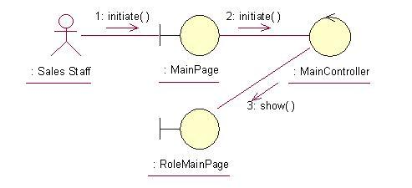
The above collaboration diagram shows the process flow after the actor has login.
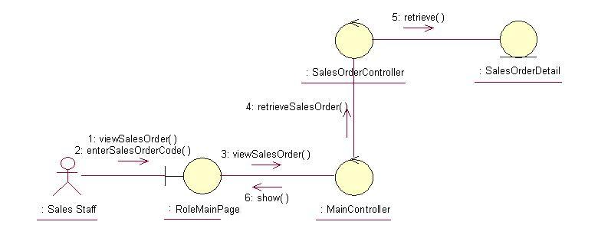
The above collaboration diagram shows the main process flow of this use case.

Participating Objects

Sales Staff
This actor represents the sales staff that will have a web page console to monitor and update the sales order information.

Main Page
This object renders the contents after the actor has login. The Director, Department Manager and Operation Manager actors use this object.

Role Main Page
This object renders the contents (based on the user role) after the actor has login. The Director, Department Manager and Operation Manager actors use this object.

Main Controller
This object acts as the middleman between Main Page and the SalesOrderController. It will translate interactions with the view into actions to be performed by the SalesOrderController.

Sales Order Controller
This object acts as the middleman between related Sales Order Pages and the Sales Order and Sales Order Detail objects. It will translate interactions with the view into actions to be performed by the Sales Order or Sales Order Detail objects.

Sales Order Detail
This object stores the details concerning the Sales Order Detail of the COMS.

Class Diagrams

Domain Class Diagram: View Sales Order
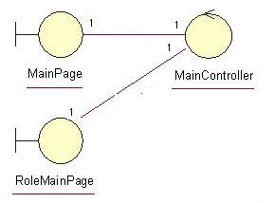
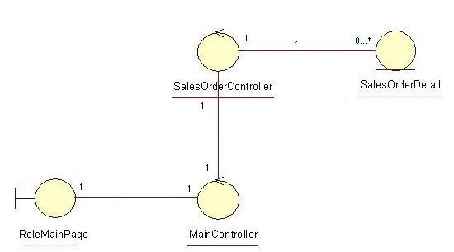

Derived Requirements
The Sales Staff PC keyboard and mouse / barcode scanner will be used to retrieve Sales Order details (if any) and view all the system responses.

